Ecclesiastical petition requesting the consecration of a newly constructed parish church in Buckingham
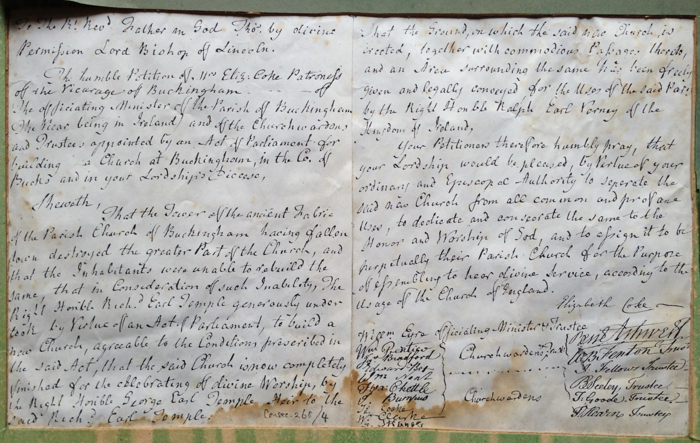
The Petition to The Bishop of Lincoln
Summary: This document is a formal ecclesiastical petition addressed to Thomas, the Lord Bishop of Lincoln. It requests the consecration of a newly constructed parish church in Buckingham. The petition reveals a significant local historical event: the tower of the ancient parish church collapsed, destroying most of the building. Because the local inhabitants could not afford to rebuild it, prominent nobility stepped in. Richard, Earl Temple, initiated the rebuilding through an Act of Parliament, and his heir, George, Earl Temple, completed it. Furthermore, Ralph, Earl Verney, donated the land. The document is signed by the patroness, the officiating minister, and numerous churchwardens and trustees, illustrating the collaborative effort between local church officials and wealthy benefactors in 18th or 19th-century England.
Principal Individuals:
- Thomas, Lord Bishop of Lincoln: Recipient of the petition, holding the authority to consecrate the church.
- Mrs. Elizabeth Coke: Patroness of the Vicarage of Buckingham and lead petitioner.
- Richard, Earl Temple (Right Honourable): Benefactor who generously undertook the building of the new church by virtue of an Act of Parliament after the original was destroyed.
- George, Earl Temple (Right Honourable): Heir to Richard, Earl Temple; he saw the church to its complete finish.
- Ralph, Earl Verney (Right Honourable): Of the Kingdom of Ireland; freely gave and legally conveyed the ground and surrounding area for the new church.
Associated Individuals (Petitioners/Signatories):
- William Eyre: Officiating Minister & Trustee
- William Prentice: Churchwarden & Trustee
- John Bradford: Churchwarden & Trustee
- Edward Box: Churchwarden
- William Nott: Churchwarden
- Francis Chettle: Churchwarden
- J. Bumpus: Churchwarden
- James Cooke: Churchwarden
- William Clarke: Churchwarden
- W. Skinner: Churchwarden
- Rene Ashwell: Trustee
- W.B. Fenton: Trustee
- J. Fellows: Trustee
- B. Seeley: Trustee
- T. Goode: Trustee
- P. Hearn: Trustee
Key Events:
- Event Type: Petition for Church Consecration.
- Location: Parish of Buckingham, County of Bucks (Buckinghamshire), Diocese of Lincoln.
Geographical Locations:
- Buckingham, Co. of Bucks: The town and parish where the church is located.
- Diocese of Lincoln: The ecclesiastical jurisdiction overseeing Buckingham.
- Ireland: Mentioned as the current location of the Vicar, and the Kingdom associated with Earl Verney.
Overview:
- The document is a formal petition to the Bishop of Lincoln to consecrate a newly built church in Buckingham.
- The original church was destroyed when its ancient tower collapsed, and the locals lacked the funds to rebuild it.
- The rebuilding was funded and facilitated by local nobility, specifically Richard and George, Earls Temple, and Ralph, Earl Verney, who donated the land.
- The petition provides a valuable list of local church officials, including the patroness, minister, churchwardens, and trustees active at the time of the church's completion.
This is the Full Text
To the Rt Revd Father in God Thos by divine Permission Lord Bishop of Lincoln.
The humble Petition of Mrs Eliz: Coke Patroness of the Vicarage of Buckingham - of the officiating Minister of the Parish of Buckingham (the Vicar being in Ireland) and of the Churchwardens and Trustees appointed by an Act of Parliament for building a Church at Buckingham, in the Co. of Bucks and in your Lordship's Diocese, Sheweth, That the Tower of the ancient Fabric of the Parish Church of Buckingham having fallen down destroyed the greater Part of the Church, and that the Inhabitants were unable to rebuild the same, that in Consideration of such Inability, The Right Honourable Richd Earl Temple generously undertook by Virtue of an Act of Parliament, to build a new Church, agreeable to the Conditions prescribed in the said Act, that the said Church is now completely finished for the celebrating of divine Worship, by the Right Honourable George Earl Temple Heir to the said Richd Earl Temple. Consec. 268/4
That the Ground, on which the said new Church is erected, together with commodious Passages thereto, and an Area surrounding the same has been freely given and legally conveyed for the Uses of the said Parish by the Right Honourable Ralph Earl Verney of the Kingdom of Ireland,
Your Petitioners therefore humbly pray, that your Lordship would be pleased, by Virtue of your ordinary and Episcopal Authority to separate the said new Church from all common and profane Uses, to dedicate and consecrate the same to the Honor and Worship of God, and to assign it to be perpetually their Parish Church for the Purpose of assembling to hear divine Service, according to the Usage of the Church of England.
Elizabeth Coke Willm Eyre officiating Minister & Trustee Wm Prentice } Churchwardens & Trust[ees] Jno Bradford } Edward Box Wm Nott Fra: Chettle J. Bumpus } Churchwardens Ja. Cooke Wm Clarke W. Skinner Rene Ashwell W.B. Fenton Trust[ee] J. Fellows Trustee B. Seeley, Trustee T. Goode, Trustee P. Hearn Trustee

And this is the response from the Bishop of Lincoln consecrating the new church for divine worship.
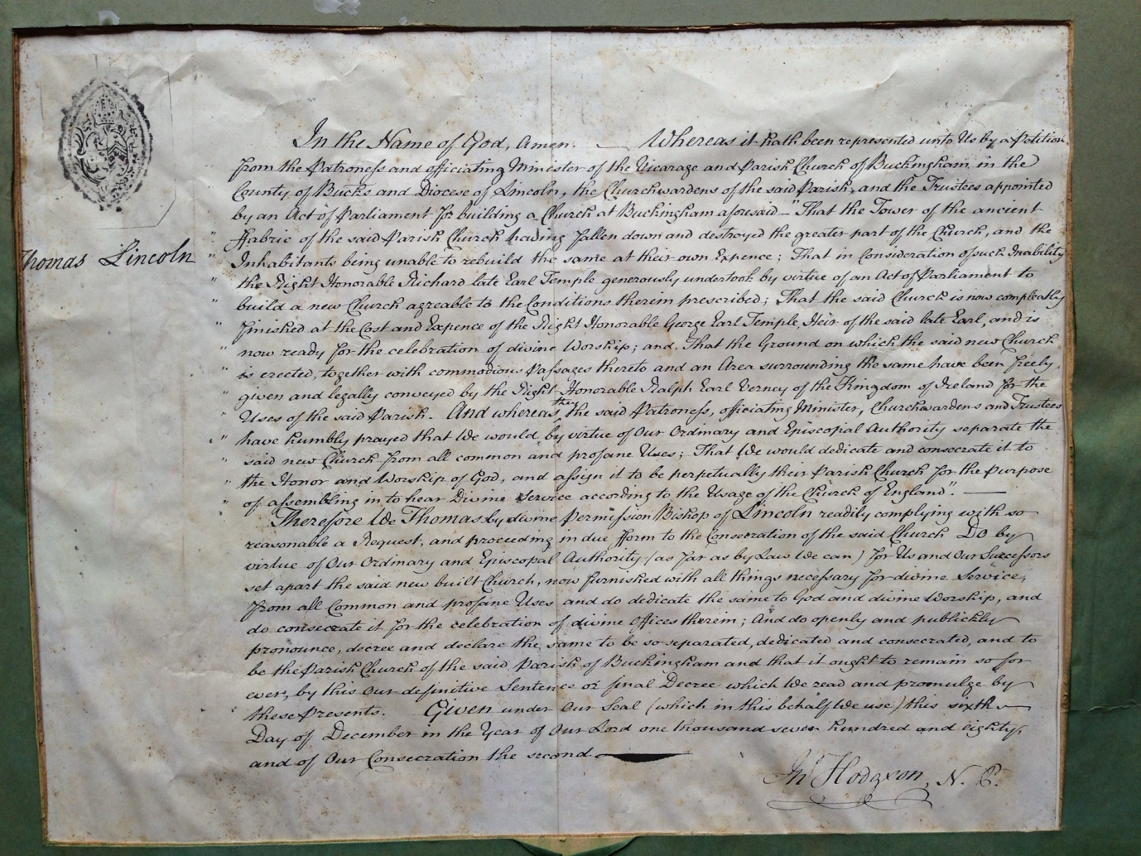
In the name of God, Amen. Whereas it has been represented unto us by a petition from the patrons and officiating minister of the vicarage and Parish Church of Buckingham in the county of Bucks and Diocese of Lincoln, the Church Wardens of the said parish, and the trustees appointed by an act of parliament for building a church at Buckingham aforesaid. That the Tower of the ancient fabric of the said Parish Church having fallen down and destroyed the greater part of the church, and the inhabitants being unable to rebuild the same at their own expense; that in consideration of such inability the Right Honourable Richard late Earl Temple generously undertook by virtue of an act parliament to build a new Church agreeable to the condition therein prescribed; that the said Church is now completely finished at the cost and expense of the Right Honourable George Earl Temple, heir of the said late Earl, and is now ready for the celebration of divine worship; and, that the ground on which the said new Church is erected, together with commodious passages thereto and an area surrounding the same have been freely given and legally conveyed by the Right honourable Ralph Earl Verney of the Kingdom of Ireland for the uses of the said parish. And whereas they said patrons, officiating minister, Church Wardens and trustees have humbly prayed that we would by virtue of our ordinary and Episcopal authority separate the said new Church from all common and profane uses; that we would dedicate and consecrate to the honour and worship of God, and assign it to be perpetually their parish Church for the purpose of assembling in to hear divine service according to the usage of the Church of England. Therefore we Thomas by divine permission Bishop of Lincoln readily complying with so reasonable a request, and proceeding in due form to the consecration of the said Church by virtue of our ordinary and Episcopal authority as far as by law we can, for us and our successes set apart the said new built Church, now finished with all things necessary for divine service, from all common and profane uses and do dedicate the same to God and divine worship, and do consecrate it for the celebration of divine offices therein; and do openly and publicly pronounce, decree and declare the same to be so separated, dedicated and consecrated, and to be the parish Church of the said parish of Buckingham and that it ought to remain so forever, by this our definitive sentence or final decree which we read and promulgate by these presents. Given under our seal (which in this behalf we use) this sixth day of December in the year of our Lord 1780 and of our consecration the second.

