

Annual Report and Financial Statements
of the Parochial Church Council for 2025



Presented to the Annual Parochial Church Meeting on Sunday 26 April 2026 at 10.30am

Contents
Charity Information 3
Agenda 4
The Minutes of the APCM Meeting 2025 6
The Annual Report – 2025 9
Trustees Report - Year ended 31st December 2025 10
Children and Families Update: Lucia Pearson-Gee 16
Youth and Students Update: Sam Graham 17
Mission and Outreach Report: Keith Croxton 18
Fabric Update: Nigel Collison 20
Health and Safety Update: Nigel Collison 21
Electoral Roll Update: Heidi Buchan 22
2025 Church Attendance 23
Rector’s Report 2025 27
Finance and Stewardship Committee 29
Stewardship Update: Brian and Tracy Roskell 29
Independent Examiner's Statement for the year ended 31 December 2025 30
Financial Statements for the year ended 31 December 2025 31

Charity Information

Buckingham Parish Church,
Castle Street,
Buckingham MK18 1BS
Parish Office 01280 821509 www.bpchurch.uk

Charity No 1128704

Incumbent: The Revd Will Pearson-Gee
The Rectory, 8 Aris Way, Buckingham MK18 1FX

Churchwardens: Mr Gerry Causer
99 Burleigh Piece, Buckingham, MK18 7BT

Mrs Glynnis Eastwood
2 Wren Close, Buckingham, MK18 7HA

Banks: CAF Bank Ltd
25 Kings Hill Avenue, Kings Hill, West Malling, Kent ME19 4JQ

Lloyds TSB Bank
30 Market Square, Brackley NN137BA

Accountant: Martin Nye Limited
186 High Street
Winslow
MK18 3DQ

Agenda

The Annual Meeting of Parishioners (AMP)

Opening Hymn: Be Thou my Vision NEH 339
1 Appointment of Secretary for the meeting
2 Apologies for absence
3 Election of Church Wardens (during which any parishioner – as well as those on the Electoral Roll -
may vote.)

Annual Parochial Church Meeting (APCM)

1 Approval of the Minutes of the Annual Parochial Church Meeting held on 11 May 2025
2 Matters Arising
3 Presentation and Approval of the Electoral Roll (ER)
4 Elections and Appointments (only those on the ER may vote)
a. Election of the Deputy Wardens
b. Election of the Parochial Church Council (PCC)
c. Election of the Deanery Synod
d. Prayers for those elected
Song: King of Kings

5 Stewardship and Finance Reports
6 Presentation of the Annual Report and Accounts
7 Appointment of Auditor for 2026
a. Prayers for our Finances and Stewardship, led by Joyce Wallace
8 Children and Families Report, presented by Lucia Pearson-Gee
9 Youth Report, presented by Sam Graham
10 Mission and Outreach Report, presented by Revd Jo Wigley
a. Prayers for these ministries
11 Reading: Haggai 1 (omitting v 10 and 11) by Victoria Morrell

Song: O Praise the Name
12 Rector’s Report and Look Ahead
13 Any Other Business (AOB - any items for discussion should be notified to the Rector at least 24
hours before the meeting or they may not be taken.)
14 Q&A during which children are collected
(It is very much hoped that any detailed questions on the accounts can be asked and answered via
email before the meeting).

15 Holy Communion

Hymn: O Lord my God/How Great Thou Art (MP 506 – omit v 2)
16 Closing Prayer and Thanksgiving for Food

The Minutes of the APCM Meeting 2025

MEETING OF: Annual Parochial Church Meeting of Buckingham Parish Church
DATE AND TIME: Sunday 11th May 2025 at 10.30am
Annual Meeting of Parishioners
1 Appointment of Secretary for the meeting
Sue Fox was proposed by Elaine Causer and seconded by Mandy Hagon. All voted in favour.
2 Apologies for Absence
223 people attended the meeting, and 17 apologies were recorded.
3 Election of Church Wardens
There were two nominations for Church Warden.
Gerry Causer was proposed by Keith Croxton and seconded by Tracy Roskell.
Glynnis Eastwood was proposed by Gill Stopps and seconded by Divya Jacob.
There being no other nominations, they were duly elected.

Annual Parochial Church Meeting
1 Approval of the Minutes of the Annual Meeting held on 28 April 2024
Paul Hirons proposed and Harry Morten seconded that the minutes be approved as a correct record of the APCM held on 28 April 2024. All voted in favour. WPG signed the minutes.
2 Matters Arising
There were no matters arising.
3 Presentation of the Electoral Roll.
In Heidi Buchan’s absence, WPG read out the report.
There are currently 286 on roll, as at 11th May 2025, of which 129 are non-resident of the Ecclesiastical Parish. WPG noted his thanks to Heidi for her report and work throughout the year.
The Electoral Roll was proposed by Margo Lohmann, seconded by Bill Mercer and accepted at the meeting. All voted in favour.

4 Elections and Appointments
Election of Deputy Wardens
Glynnis Eastwood proposed, and Pauline Stanton-Saringer seconded that the following Deputy Church Wardens continue in their role:

Traditional Service:
- Paddy Collins
- Lynne Legrove
- Nigel Collison
- David Squibb

Family Service: (Service Wardens)
- Zena Greig
- Cheryl Dawson
- Christine Barrell
- George Onaya

Evening Service:
- Andrew Grimditch
- Steven Tayfield
- Max Hailey
- Mike Evans
- Matt Lambert

Election of Members of the Parochial Church Council
Lorna Piper was proposed by Tracy Roskell and seconded by Harry Morten. All voted in favour.
WPG noted his thanks to Lorna for all she does for BPC.

Paul Hirons and Andy Pallett have stepped down from the PCC and were thanked by Will.

Lara Burt was proposed by Anne Exelby and seconded by Gill Stopps to be elected onto Deanery Synod.

Revd Jo Wigley prayed and gave thanks for those serving on the PCC.
5 Hymn
WPG acknowledged Tina Mitchell’s generosity that has enabled us financially to complete the Organ Project, in memory of Ray Mitchell.
6 Church Attendance Reports
WPG thanked Lorna Piper for her work on BPC’s attendance records. Figures are extremely
encouraging and have increased at both the 11am and 6pm. The 9am service attendance dipped slightly when our asylum seekers left BPC.
7 Stewardship and Finance Reports
Harry Morten presented the Finance report.
Brian Roskell presented the Stewardship report. He thanked the congregation for their faithfulness and giving.
8 Presentation of the Annual Report and Accounts
Harry Morten proposed, and Matt Lambert seconded that this meeting approve the Accounts. All voted in favour. Harry Morten acknowledged the work carried out by Tracy Roskell in relation to Finance and Stewardship.
Harry Morten proposed, and Paul Hirons seconded that this meeting approve the reappointment our Independent Examiners, Martin Nye.
Tina Mitchell prayed for the Finances of the Church.
9 Hymn
10 Children and Families Ministry
A video of the Children and Families Ministry was presented by Lucia Pearson-Gee.
The Children’s and Families Ministry at BPC saw a year of growth and transformation and is now one of the largest Ministries in the Diocese.
Overall, the ministry is thriving, with strong volunteer support, community engagement, and a renewed focus on sustainability and spiritual growth. Lucia is praying for someone to step up as her “Second in Command.”
After this presentation, WPG noted the success of Holiday Club 2024.
11 Youth Ministry
A video and talk of the Youth Ministry was presented by Sam Graham.
Sam highlighted a successful year for the Youth Ministry at Buckingham Parish Church. Key achievements included the continued growth including the Monopoly Challenge in London, 14 young people attended DTI, 7 young people were baptised. Youth Ministry has doubled in size and space is an issue.

Sam concluded by reaffirming the ministry’s mission to help young people know, love, and live for God, celebrating strong progress in 2024 with hopes to grow further in 2025.

12 Mission and Outreach
A video of the Mission and Outreach was presented by Revd Jo Wigley.
The Mission and Outreach Group (MOG) oversees various community activities at Buckingham Parish Church. Keith Croxton leads this group, overseeing The Centre (hosting the Food Bank, Coffee and Company, sewing group "Sew Lovely," and Greek and Hebrew lessons), Community Lunches, Men’s Ministry, Bradford Link, and wider mission initiatives. MOG also supports Alpha courses—recently resulting in several baptisms—and partners with a youth club to engage young people.
Keith and Mandy Hagon were acknowledged as Connect Group Leaders, who are now leaving BPC. Phil and Gill Blackledge are taking over this role.
Gill Croxton led the prayers for the above Ministries.
13 Thanking the Retired Clergy and LLM’s
Gerry Causer thanked the retired clergy and the LLM’s for all they do.
14 Rector’s Report and Look Ahead.
The Rector reflected on 15 happy and fruitful years in Buckingham. He then thanked the church family and the amazing team of volunteers, the generous givers and the staff team.
The Rector closed with a call to faith, prayer, service, generosity, and an encouragement to dive deeper into God's work without fear.
15 Any other Business
There was no other business.
16 Questions and Answers
There were no Questions
17 Holy Communion
18 Closing Prayer and Thanksgiving for Food.

The Annual Report – 2025

Background and Statement of Facts

Buckingham Parish Church is part of the Buckingham Benefice along with the Parish of St John the Evangelist, Radclive cum Chackmore.

The Rector and the Parochial Church Council (PCC) consult together on matters of general concern and importance to the Parish. The PCC co-operates with the Rector in promoting in the Parish the whole mission of the Church, pastoral, evangelistic, social and ecumenical in order to implement its vision “To Worship God, Make Friends and Change the World”. The PCC also considers and discusses matters concerning the Church of England or any other matters of religious and public interest (but not the declaration of the doctrine of the Church on any question) and raises such matters as the Council considers appropriate with the Deanery Synod and Diocesan Synod.

The Parochial Church Council

The following served as members of the PCC during the year 2025:

Incumbent The Revd Will Pearson-Gee
Associate Minister The Revd Jo Wigley
Curate The Revd Ope Ayileye

Churchwardens Mr Gerry Causer
Mrs Glynnis Eastwood

Deputy Churchwardens Mr Paddy Collins (non-PCC)
Mrs Lynne Legrove (non- PCC)
Mr Andrew Grimditch (non-PCC)
Mr Steven Tayfield (non-PCC)
Mr Matt Lambert (non-PCC)
Deanery Synod Reps Mr Paul Wallace
(Until APCM) Mr Gerry Causer
Dr Andrew Gibson
Ms Beth Jeremy
Mrs Lara Burt

Elected Members:
There can be up to 15 elected members on the PCC, 4 being elected each year to serve for 3 years.

Mr Nigel Collison (Fabric) Mr Mike Evans
Mr Andrew Miscampbell Mr Simon Morrell
Mr Harry Morten (Finance) Mr George Onaya
Mr Andy Pallett Mrs Lorna Piper
Mr Brian Roskell (Stewardship) Mr Mike Roskell (Production)
Mrs Tracy Roskell (Treasurer)

Until APCM 2025
The PCC also has the responsibility for the care and maintenance of Buckingham Parish Church, the lavatory block on Church Hill, 5 Chandos Close (the Curate’s house) and The Centre in Verney Close.

Trustees Report - Year ended 31st December 2025

The Trustees present their trustees’ report on the unaudited financial statements for the year ended 31st December 2025. The financial statements have been prepared in accordance with the accounting policies set out in the notes to the financial statements, the Charities Act 2011 and “Accounting and Reporting by Charities: Statement of Recommended Practice” applicable to charities preparing their accounts in accordance with the Financial Reporting Standard applicable in the UK and Republic of Ireland (FRS 102) (effective from 1 January 2019).

STRUCTURE, GOVERNANCE AND MANAGEMENT

Charity Information:
List of Trustees who have served during the financial year until the approval of the financial statements:

Rev Will Pearson-Gee (Incumbent)
Mrs Lara Burt (Deanery Synod)
Mr Gerry Causer (Church Warden and Deanery Synod)
Mr Nigel Collison
Mrs Glynnis Eastwood (Church Warden)
Mr Mike Evans
Dr Andrew Gibson (Deanery Synod)
Ms Bethan Jeremy (Deanery Synod)
Mr Andrew Miscampbell
Mr Simon Morrell
Mr Harry Morten
Mr George Onaya
Mrs Lorna Piper
Mr Brian Roskell
Mr Michael Roskell
Mrs Tracy Roskell
Mr Paul Wallace (Deanery Synod)

Governing Document
The constitution and rules for proceedings of the PCC are set out in the Parochial Church Council Powers Measure (1956) as amended and Church Representation Rules as amended on 21/09/2021.

Reference and Administrative Details
• Registered with the Charity Commission on 20 March 2009
• Charity Registration Number 1128704
• Address: Castle Street, Buckingham, MK18 1BS

Parish / Benefice Staff
• Revd Will Pearson-Gee has now been in post as Rector for 16 years
• Revd Jo Wigley continued to serve as Associate Minister for Pastoral Care from 2017
• Revd Ope Ayileye continued to serve as Curate (Self-Supporting) from 2022
• Robert Tucker continued to serve as Organist and Choir Master
• Ali Burt continued to serve as Production Assistant and Worship Administrator from 2024
• Sam Graham continued to serve as Youth and Students’ Pastor from 2021. He also continued in his additional role as Worship Leader.
• Lucia Pearson-Gee continued to serve as Children and Families’ Pastor from 2023
• Divya Jacob continued to serve as Operations Manager with additional HR role from 2024
• Sue Fox continued to serve as PA to the Rector from 2014
• Lara Burt continued to serve as Office Administrator and Communications Lead from 2021
• Amir Kamali continued to serve as Caretaker of The Centre from September 2024
• Paul Wallace, Pauline Stanton-Saringer and Paul Mileham officiated as LLMs
• Keith Croxton has a preaching licence
• Revd Keith Hagon served as a licensed preacher from July 2023 until August 2025
• Revd Maurice Stanton-Saringer, Canon Dr Peter Williams, Revd Ron Bundock, Revd Chris Murray and Canon Max Wigley assisted as retired clergy with PTO

Review of PCC discussions in 2025
During the year the PCC met for 4 scheduled meetings and had an average attendance of 54%.

Main items discussed were:
The Alpha Course; issues regarding human sexuality affecting the CofE; the employment of a new Worship Pastor; the Window Repair Project; the organisation of Holiday Club; and the prospect of a Curate were discussed most frequently.

Standing Committee
The Standing Committee (SC) is a statutory requirement. It meets to prepare the agenda for the PCC and has power to transact business of the PCC in emergencies between its meetings, subject to any directions given by the PCC. The PCC has delegated to the SC responsibility for Human Resources (HR) matters concerning non-clergy paid members of staff. The Churchwardens, Head of the Finance and Stewardship Committee, Treasurer, PCC Secretary and up to two other members of the PCC serve on the SC which is chaired by the Rector. It meets every month that the PCC does not and meets via Zoom.

Other Committees and Working Groups
The PCC operates through a number of sub-committees and working groups, which are responsible for areas of activity. They meet between PCC meetings giving reports and, where appropriate, making recommendations to the PCC and implementing decisions by the PCC when asked to do so. These sub-groups are The Mission and Outreach Group (MOG), and Stewardship and Finance and they have shared their reports in this document.

Recruitment and Appointment of Trustees
Most Trustees (members of the PCC) are either ex officio or are elected by the Annual Parochial Church Meeting (APCM) in accordance with the governing document (Church Representation Rules). Some others are co-opted for particular purposes. The APCM and elections of PCC members will take place on 26th April 2026.

New Trustees receive an induction on their role and responsibilities from the Secretary of the PCC and any relevant documents and guidelines, in addition to a general induction from the Chairman during the first meeting of the year following each APCM.

OBJECTIVES AND ACTIVITIES
The objectives of the Charity are to worship God, follow God's way, make God's love known. We want to honour God and build His Kingdom here in Buckingham as a church family. We believe that God has given us a vision where the church will be a thriving, relevant and caring Christian community serving the town.
It will be a place where all can grow, seek God and a place where lives will be transformed and changed forever. Our vision is encapsulated in three foundational activities as follows:

BPC is a community that:
- Worships God
- Makes Friends and
- Changes the World

These activities are anchored in our core values. These values underpin all we do, how we should act and how we should seek to live out the vision God has given us. Our core values are:
- Compassionate
- Courageous
- Spirit led
- Servant-hearted
- Fun-loving
- Jesus centred
- Joyful
- Outward looking
- Do things well
- Generous
- Passionate
- Loving
- Prayerful
- United not uniform
- Bible-based

We worship God - Through excellent, inspiring and engaging worship we want to draw more people into a deeper on-going relationship with God, where worship truly becomes everything in our lives.
This is where we ‘plug-in’.

Make Friends - We will be a loving and accepting community where people are welcomed and deep/genuine relationships are grown to help us be the best we can be and grow more like Jesus.
- Our small groups (known as ‘Connect Groups’) are key to this component and where deep discipleship takes place and leaders are identified and nurtured. Prayer, fellowship and Bible study are the core elements of our CGs.
- Our leadership pipeline develops new leaders.
- We aspire to offer a warm welcome and great hospitality at all services.
- We are intentional about holding events throughout the year for people to connect with. And these events range from a barn dance through to parish weekends away.
This is where we ‘charge-up’.

Change the World - We want to equip and encourage people to recognise and use their God-given gifts to make a difference in Buckingham and the World.
- Running regular Alpha courses is a key part of our mission and outreach whereby we follow the Great Commission.
- We send mission teams out every year to make a positive difference in different parts of the world.
- We encourage the discernment of gifts and make training available to develop skills;
- Growing our Mission and Outreach portfolio locally and further afield.

The charity aims to:
- Makes grants to organisations – we giveaway 10% of our income (excluding restricted/dedicated income) to support other charities.
- Provide buildings/facilities/open space for use by the wider community.
- Provide services for the vulnerable, isolated, elderly and the needy.

Public Benefit
In setting objectives and planning for activities, the Trustees have given due consideration to general guidance published by the Charity Commission relating to public benefit, including the guidance 'Public benefit: running a charity (PB2)'.

The Church provides public Benefit through a range of activities including:

Alpha Team – The Alpha Course is one of the main ways people come to faith at BPC, so every term we gather as many people as we can to explore Christianity in this relevant and relaxed way. The team includes those who bring guests, set up, lead groups or are just great hosts.

Childrens’ Team – We have a number of age-appropriate groups running every Sunday and at special events — from babies through to 11 year olds. Our Childrens leaders work together as they invest in our children through all sorts of videos, games, crafts, music and stories, bringing Jesus to life in their lives. We also run an annual Holiday Club for the wider community.

Families Team – Reaching out into our community is at the heart of what this team does. We run The Ark Baby and Toddler Group, Lighthouse (after-school church), an annual Family Fun Day, engage with local schools through assemblies, a Light Party and Easter and Christmas events.

Youth Team – Our youth are 11-18 years of age and meet during the 11am and 6pm service every week to hang out, experience faith in engaging ways and discover what it means to live out that faith in today’s world. This team run the sessions and arrange other special events throughout the year. The Team also supports Project Street Life which serves the youth in the wider community.

Worship Team – A group of passionate musicians and singers who have been chosen to lead our Sunday worship and other events, preparing the way for people to encounter the presence of the living God.

Food Bank - We run a local Foodbank distributing non-perishable and fresh food in Buckingham and the surrounding villages.

The PCC wishes to thank all our volunteers for their support, without their continued support, the Church would be unable to function as a resource available to the public.

ACHIEVEMENTS AND PERFORMANCE
Please see the Rectors Report for details of our achievements during the year.

RESERVES POLICY AND FINANCIAL REVIEW
The Trustees have agreed that the reserves policy should enable the funding of the equivalent of three months’ costs (approximately £120k).

At the end of 2025, our total reserves were £707k (2024: £692k), of which £188k (2024: £174k) are regarded as free reserves and £519k (2024: £518k) are restricted funds. We therefore have sufficient funds to comply with our reserves policy.

The principal funding source of the charity is the regular giving by the congregation. This has increased from £386,174 in 2024 to £461,589 in 2025. Of this, £73,311 (2024: £68,042) was received via gift aid.

Expenditure on general repairs have increased substantially this year as we carried out work to repair and refurbish a number of our stained-glass windows.

The notes to the accounts provide details of the various funds held at the year end.

PLANS FOR FUTURE PERIOD
At Buckingham Parish Church we continue to seek to teach, understand and follow the whole message of the Bible. Our desire is to share this message as widely as possible within our community, schools, University and local villages. We seek to grow the church in depth, in outreach and in size and we want to continue the great work that is going on at The Centre, including the provision of the food bank. Our work with children and youth is growing year on year and we want to continue to nurture these younger generations and see every young person reach their full potential as a disciple of Jesus. As we grow we need to find more space (buildings) and this search will be a major aspect to our plans for 2026.

Going Concern
After making appropriate enquiries, the Trustees have a reasonable expectation that the Charity has adequate resources to continue in operational existence for the foreseeable future. For this reason, they continue to adopt the going concern basis in preparing the financial statements. Further details regarding the adoption of the going concern basis can be found in the accounting policies.

Risk Management
The Trustees are exposed to a number of risks: financial; safeguarding; legal compliance; buildings and infrastructure; and pastoral oversight. Each area of potential risk is reviewed on a regular basis by the Trustees and plans are in place to manage the risks.

• The annual budget for the financial year is approved by the PCC in the prior year’s December meeting. Performance against the budget is reviewed at each meeting of the PCC and Standing Committee. The Finance Team meet on a quarterly basis to review the finances in greater depth and bring any areas of financial concern to the attention of the Standing Committee at the earliest opportunity.
• Buckingham Parish Church places the highest priority on safeguarding the welfare of the children, young people and vulnerable adults in its care, and as is required by the Church of England and by law, it has effective arrangements in place to protect them. These are set out in the Parish Safeguarding Policy which is reviewed and approved annually by the PCC. This document is on display in church and is available on the Safeguarding page of the church website. The Parish safeguarding procedures and volunteer recruitment processes are also available on the website. The church is registered on the Diocesan Safeguarding Dashboard, which enable the PCC and the Safeguarding Officers to monitor the implementation of safeguarding measures. Jane Wardale and Glynnis Eastwood have been appointed by the PCC as the Parish Safeguarding Officers.
• The PCC is committed to meeting its legal responsibilities and regularly reviews the Health & Safety and Data Protection Policies.
• Our building is insured and inspected under a quinquennial regime. The last inspection was carried out in 2024. All maintenance and repairs are carried out under the direction of our Fabric Chair.
• Pastoral care is provided by our Associate Minister for Pastoral Care, along with other clergy and lay members of the church. Volunteers are carefully selected for key roles such as prayer ministry or leading Connect Groups. Training is provided and the volunteers are supported by and accountable to senior clergy. Our insurance includes pastoral care indemnity cover for clergy and staff.

Responsibilities of the Parochial Church Council (The Trustees)
The Trustees are responsible for preparing the Trustees’ Report and the financial statements in accordance with applicable law and United Kingdom Accounting Standards (United Kingdom Generally Accepted Accounting Practice).

The law applicable to charities in England and Wales requires the trustees to prepare financial statements for each financial year which give a true and fair view of the state of affairs of the charity and of the incoming resources and application of resources of the charity for that period. In preparing these financial statements, the Trustees are required to:

- select suitable accounting policies and then apply them consistently;
- observe the methods and principles in the Charities SORP 2019 (FRS102);
- make judgements and estimates that are reasonable and prudent;
- state whether applicable accounting standards have been followed, subject to any material departures disclosed and explained in the financial statements;
- prepare the financial statements on the going concern basis unless it is inappropriate to presume that the charity will continue in operation.
The trustees are responsible for keeping accounting records that disclose with reasonable accuracy at any time the financial position of the charity and enable them to ensure that the financial statements comply with the Charities Act 2011, the Charity (Accounts and Reports) Regulations 2008 and the Church Accounting Regulations 2006. They are also responsible for safeguarding the assets of the charity and hence for taking reasonable steps for the prevention and detection of fraud and other irregularities.

The Trustees oversee and support the Leadership Team, the staff and the members of Buckingham Parish Church in their various areas of ministry and are responsible for ensuring that a representative (usually the Chairman) reports back to the Church members annually at the APCM along with other ministry leaders. This meeting also includes election of new Trustees and is open to all to attend, although only those named on the Electoral Roll or living in the Parish may vote in this matter. A detailed report of ministry activities for the previous twelve months is made available at this meeting, along with copies of the Annual Report and Financial Review.

Signed on behalf of the Parochial Church Council on 26th March 2026 by
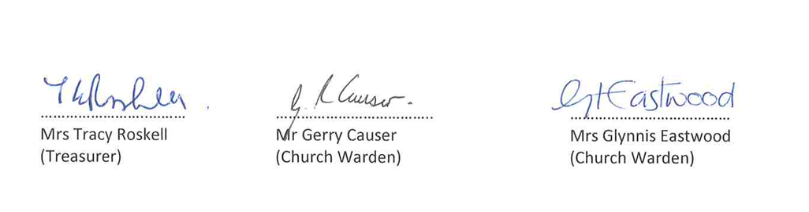

Children and Families Update: Lucia Pearson-Gee

We have continued to see an increase of children attending the 11am family service which provides four separate teaching groups:

Bubbles: (age 0-3) held in the Tower room and is mainly parent led with an overseer.
There is an average of 6 children each week, peaking in May with 9 attending.

Splash: (ages 3-5yrs) the first half of the year saw an average of 8 children which has increased to 12 regularly attending each Sunday.

Streams: (School Year groups 1, 2 and 3) has remained steady all year with 12-14 children each week with evenly matched numbers of boys and girls attending.

Waves: (School Year groups 4, 5 and 6) average weekly attendance remains at 15-17 children. Peaking at 20 children in May and December which was way too crowded for the North room and therefore we were unable to run the proper teaching programme due to space. We have only 3 girls and 12 Boys regularly attending each week.

Oceans: (School Years 2, 3, 4, 5 and 6) runs in the 6pm service, with an average of 8 children regularly attending each week with the maximum number of 10 in November.

Lighthouse Monthly Messy Church: This provides more structured crafts with a theme and interactive talk and worship followed by a two-course free meal seeing an average of 38 Children and 18-20 parents each month. We reviewed this Group in the Autumn term and decided to trial run children only going forwards.

The Ark: We have seen a huge increase in the numbers of mums and toddlers attending as well as many new-borns coming. We peaked at 79 children in July which was too many for the space, but the weekly average attendance was 56 children ages 0-4 plus their carers.

Easter Cracked: We run this annual event where we invite all the local primary schools in Year 5 or 6 to hear the Easter Story. We had 3 schools who came with 196 children plus teachers and parent helpers. George Grenvillle Academy brought 2 year groups. Feedback was all very positive.

The Light Party: This is an annual event that takes place on the 31st October and is an alternative to Halloween. We had 79 children plus parents attend.

Christmas Unwrapped: We run this event alongside Well Street United Church where the children start off their journey and then they enter a series of rooms at BPC to hear the Christmas story told through wonderful actors/actresses and two crafts. 6 schools attended, 247 children plus teachers and parent helpers.

Youth and Students Update: Sam Graham

The Youth Ministry had a great year in 2025 as we looked to fulfil our vision of encouraging young people
to Know God, Love God and Live for God.

The Students Dinners had a great year. We saw up to 35 students join us for Dinner, worship and Bible study each month.

The Way is the youth groups for the 9am, 11am & 6pm services for those in school years 7-13. With a new group at 11am launched in September and two groups at 6pm.

Youth Hub is our youth connect groups. In 2025 we started a second hub, now hosting two groups, one of school years 7-9 and the other for years 10+.

The Youth Café has been led by Project Street Life since 2023. However, BPC still supports the project as a ministry opportunity.

Schools’ Work in 2025 saw the mentoring project in The Buckingham School continue. Sam mentored 7 young people over the year seeing success in improved behaviour in school and mental health. We also continued to support the Christian Union at The Royal Latin School with regular worship leading for the group.

DTI (Dreaming the Impossible) is a Youth Festival. In 2025 we took a group of 24 young people to DTI for the fourth time, 10 more than 2024.

Youth Nights changed its model in 2025, moving away from the week of evenings in August to meeting throughout the year on a Friday evening every other month. The aim of this was to see more non-Christian young people hear the gospel in an accessible way along with a big activity.

Mission and Outreach Report: Keith Croxton

Mission and Outreach is a sub group of the PCC mandated to discern and respond to the spiritual and social needs in the community: reaching out to share God’s love and compassion with others as well as supporting the wider mission of the church.

It oversees the following:
- The Centre
- Distribution of the Tithe supporting our Mission Partners
- Bradford Link
- Men’s Ministry
- Buckingham Food Bank (delivering food parcels to those in need of urgent food)
- Tuesday Lunch
- Saturday Morning Coffee Service
- Mission to the Elderly (a weekly visit/service at Clarendon House )
- Alpha
- Mini bus
- Parish Weekends
- Created Creative
The Centre is in Verney Close in the middle of town and the lease on the building runs to June 2027. The Centre seeks to provide a sacred place in the heart of the town where the love of Jesus can be experienced and activities take place providing support to the community. The following Church groups have used The Centre during 2025:
- Coffee and Company
- Tea and Chat
- Food Bank
- Alpha Courses
- Sew Lovely
- 9am congregational lunches
- Mighty Men of Valour monthly meetings
- Freedom in Christ course
- Childrens’ Group
- Prayer Ministry training
- Holiday Club prayer meetings
In addition a variety of community groups who are serving the community use The Centre, the full list is on The Centre web site.

In October 2025 The Centre celebrated 10 years since taking over the building and a series of monthly celebration suppers followed until March 2026.( We first opened to the public in March 2016)

The 2025 tithe was distributed to the following Mission Partners
- Open Doors
- Created Creative
- Bradford BD7 Churches
- Christian Concern
- CEEC
- Buckingham Churches Together Holiday Club
- SOMA (including specific donations to St Jerome Parish-Gatwikira, ACK Parish Silanga,St Thomas Dagatoreti Corner Parish and Kiberia School:projects visited by the Mission Team GAFCON)

Mission Partners receive donations for a fixed period e.g 3 years ,5 years
Occasionally as the financial year unfolds and the tithe adjusts accordingly, additional funds become available and one off donations are then made for other causes
One off donations made during 2025
- CHIT
- Bulgiri School
- Bethel Church Nepal
- Rachel Darne Cyprus

Fabric Update: Nigel Collison

Firstly, thanks must go to the PCC, the management team, and to the whole of the BPC congregation for their support and funding to enable maintenance and repair work to continue throughout 2025.

Windows
A 2024 inspection survey revealed that urgent repairs were required to many of the high-level leaded windows and, in 2025, we saw the first phase of these works take place. Four double windows were removed from the south elevation of the Nave, stripped, cleaned, rebuilt with new lead and refitted into the church. In addition, our wonderful East stained glass window above our high communion table, which was showing some gaps, was also repaired.

A Windows Bonus!
Back in the 1860’s, the porch to the main entrance was originally built with leaded windows. In recent times these have been missing and temporary, unsightly covers have been in place. This year we have been able to match the original glass and restore leaded windows back into the porch! Before and after photos are shown below.

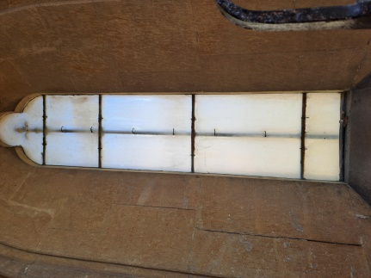
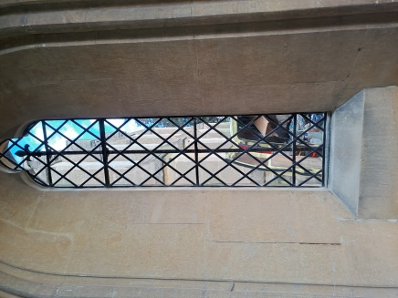

Drains
A new rainwater gully and underground drainage pipe was installed to alleviate the flooding in the boiler room.

Quinquennial Inspection Report and Architect
The 2024 QI report on the condition of the fabric of the church was finally received. The report found the church to be in good condition and the PCC was commended for continuing to maintain and improve the fabric of the building. The defects listed in the report will form the programme of repairs over the next four years. Due to relocation to the Isle of Wight, the church’s architect, Warren Whyte, has withdrawn his services. A new architect will be appointed in due course.

Bell Tower and Church Bells
Firstly, thanks should go to the bellringers for their continued maintenance and ad-hoc repairs to the church’s bells. This year, to support their work, they organised an inspection visit from The Oxford Diocesan Guild of Church Bellringers and a subsequent visit from a specialist contractor. We await their final report.

Health and Safety Update: Nigel Collison

Compliance/Inspections
Weekly, monthly and quarterly health and safety tests and inspections were carried out and recorded throughout 2025.

A fire drill was carried out during a 5pm Sunday service on 17/8/25. 180 people were safely evacuated in 2mins 30secs.

A fire risk assessment was carried out by a professional fire safety specialist in September. The areas of concern are being addressed, including the freezer on the rear fire exit route, the live electrical equipment on the balcony, housekeeping/storage of materials and fire safety training.

Incidents
There was one incident of note. A junior member of the bell ringing team suffered a fall while ringing the bells on Easter day. They were taken to A&E. Fortunately, no injury was sustained. Bell ringing supervision has now been improved and furniture and clutter from the ringing chamber has been removed.

Electoral Roll Update: Heidi Buchan

The Electoral Roll for the 2025 APCM had 286 names entered.

THERE ARE NOW 290 NAMES ON THE ROLL AS AT 26 APRIL 2026 (of which 134 are non-resident in the Ecclesiastical Parish)

2025 Church Attendance

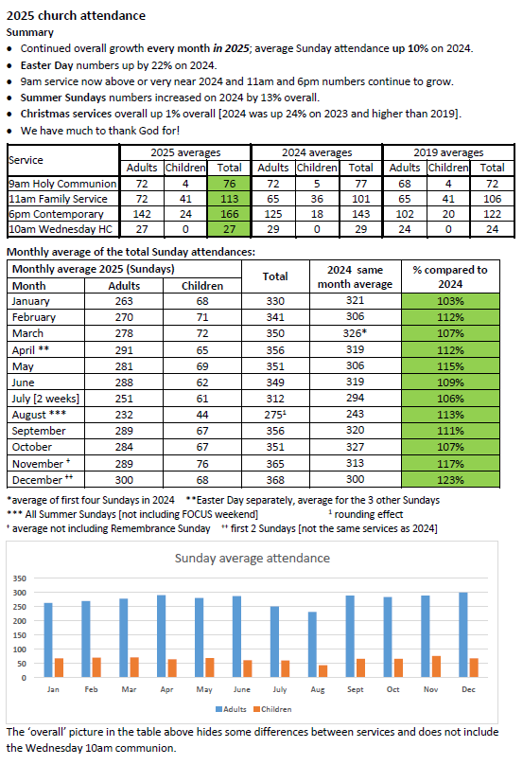

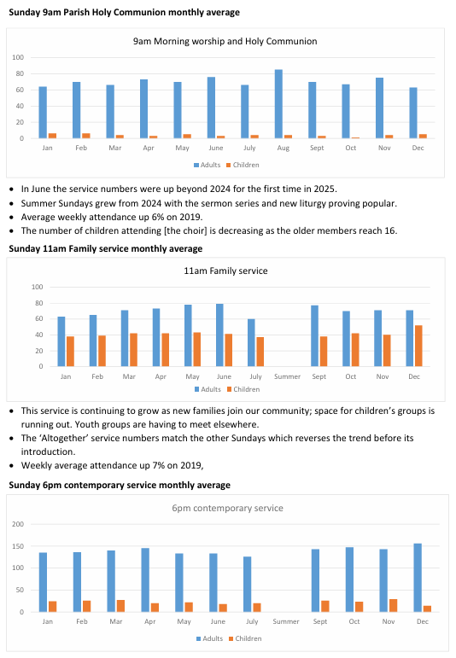

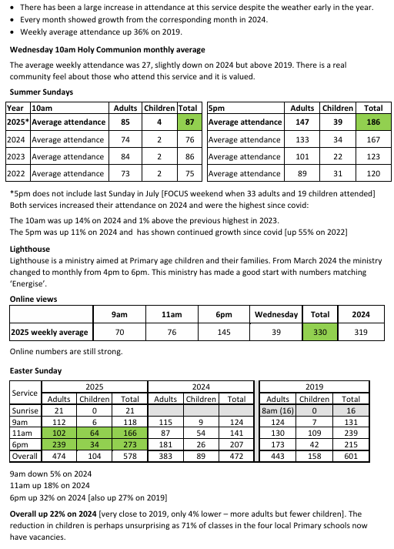

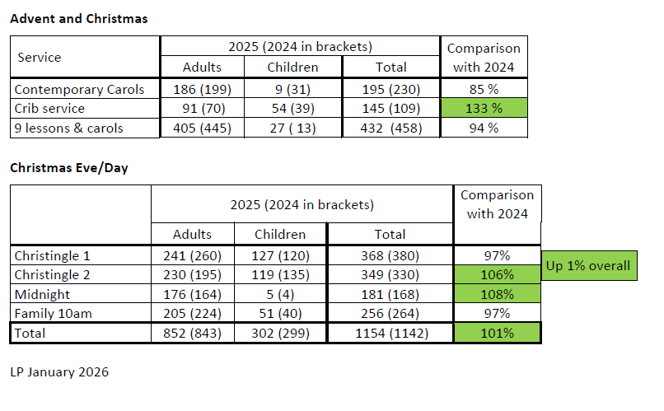

Rector’s Report 2025

As I look back over the past year, I am struck by just how much we have shared together as a church family, and how faithful God has been.

We began the year gathering for our New Year’s Eve Party, which was a wonderful expression of community and celebration. January was a full month. The Adrian Galvin Ministry Day on 18th January was very well attended and we saw many people healed in various ways. We were all encouraged by the power of the Holy Spirit. The staff team then attended the HTB ‘Summit’ Conference, which was a fantastic way to re-energise and re-envision the whole team after a very busy Christmas. Learning from those two days continued to shape our thinking and vision as a staff team.

Our Vision Sunday on 26th January gave us the opportunity to look ahead together and remind ourselves of what God is calling us to be and do as a church. Shortly afterwards, I had the privilege of serving for two weeks at the Verbier Chaplaincy.

In February, our Stewardship Sunday was uplifting and much fruit was born later in the year as a result of the teaching and exhortation to be generous.

In March it was a real joy to attend the formal welcoming service for the new Bishop of Buckingham, Dave Bull at High Wycombe, and to share in that moment with others from across the archdeaconry. We were once again delighted to host Easter Cracked, giving us the opportunity to share the Easter story with nearly 200 local schoolchildren in a creative and engaging way.

Holy Week and Easter were, as always, busy times. The Maundy Thursday Stripping of the Altar was a particularly meaningful time together, leading us into a reflective Good Friday with the Churches Together service at the Old Gaol, and then into the great celebration of Easter Sunday with three packed services including baptisms at the 6pm.

At the end of May some 35 adults and children spent a night out under canvas at Stampwell Farm for our ‘May Camp-out’. The weather was glorious and everyone had a fantastic time.

On 28th June some of us attended Revd Jo Wigley’s priesting in Great Missenden.

In late July a large group headed off to camp at HTB Focus for 5 days. This was once again a spiritual highlight. We then sent a big youth group off to Dreaming the Impossible, which was once again a huge success.
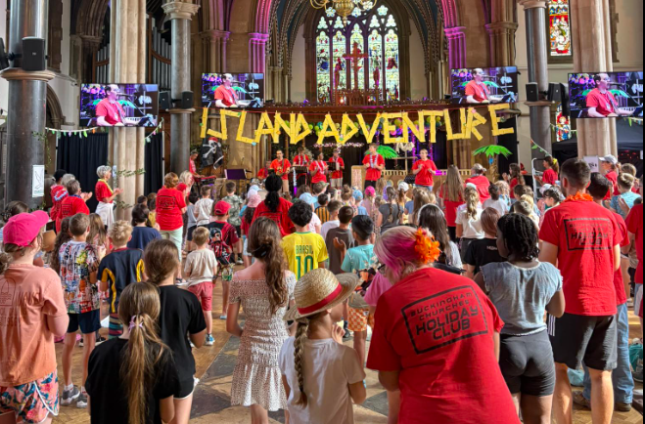

This was followed by our annual Buckingham Churches Together Holiday Club, which saw even more children signed-up.

July saw the church engage in a discernment process as to whether we should purchase a derelict set of buildings on Bristle Hill. That process continued for the rest of the year as other options were considered.

With new housing estates being built we created small welcome boxes to deliver to every new house and this led directly to new people coming to visit BPC.

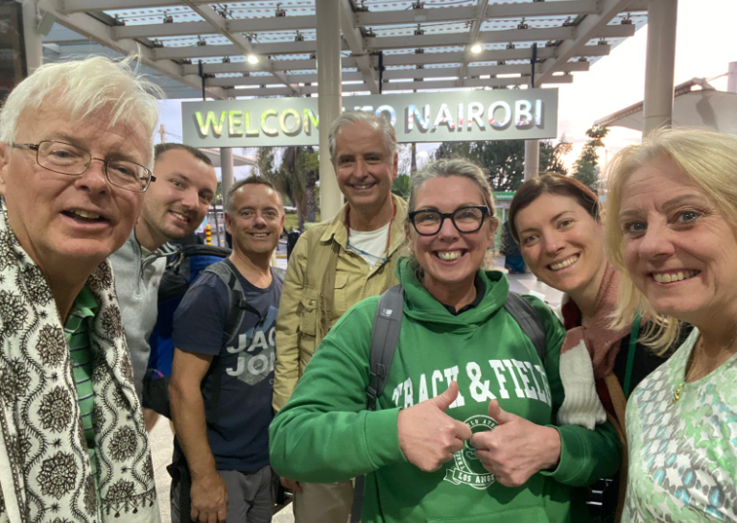

In October a team of six from BPC (and one from Berryfields Church) headed to Kenya on a SOMA mission for some 12 days. This was a challenging trip but there was much spiritual fruit.

In November we welcomed Bishop Dave for a Confirmation Service. The Remembrance Day Service was once again very well attended with over 1000 present.

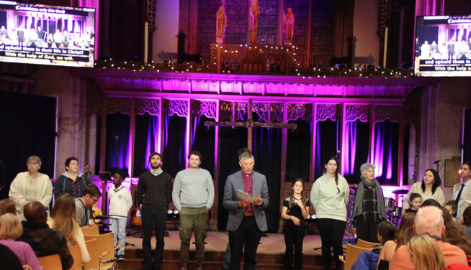

Christmas was once again very busy with all services very well attended.

Over the year we ran three successful Alpha courses, two Bereavement courses, one Divorce and Separation Recovery course and a Marriage Preparation day.

It is a real privilege to serve as your Rector, and I am continually encouraged by the way we are growing together - in worship, in faith, and in our life as a community.

As we look ahead, we do so trusting in God’s goodness, and with a renewed desire to be a church that is faithful in worship, generous in love, and bold in mission.



Revd Will Pearson-Gee
Rector

Finance and Stewardship Committee

This committee oversees the finances of Buckingham Parish Church by monitoring the income and expenditure, preparing an annual budget and coordinating the promotion of the Christian stewardship of money through planned and regular giving. The Finance and Stewardship Committee was chaired by Harry Morten (Head of Finance) and Tracy Roskell took over as Church Treasurer in 2023. Stewardship Coordinators are Brian and Tracy Roskell. (For the accounts see Finance reports on page 31).

Stewardship Update: Brian and Tracy Roskell

Significant Actions

Following the previous year’s improvement in transparency and upgraded reporting requirements, 2025 saw positive responses to requests for giving to support particular requirements. Our church activities continue to grow, underpinned by solid regular giving. The potential growth project with likely financial commitment, has focussed our minds on what is required in the near and long term future. We carefully evaluated a couple of potential opportunities and continue to seek God’s guidance in this.

Observations

- In 2025 our overall income was over 22% greater than it had been in the previous year, way ahead of our expectations.
- We ended up more or less balancing income and expenditure, having budgeted for a £70,000 deficit.
- Our expenditure was 5% more than in the previous year, enabling us to do all we had planned.
- We managed to increase the amount we tithed in supporting other organisations.
- Year to date average monthly income ended the year £8,000 ahead of the previous year.
- Standing orders were £2,237 a month more than previous year’s average, up around 12%.
- One off donations received, typically responding to particular needs including the SOMA mission trip, significantly impacted our overall year to date income, moving from an average £2,000 a month in 2024 to £5,000 a month in 2025.
- Our contactless payment machine provided an average monthly contribution of £1,168, well ahead of previous year’s £817.
- We have seen a reduction in income received from grants as our youth grant continues to drop each year, ending in August 2026. Average monthly contribution was £984.
- By the year end, we had gained 25 regular givers and lost 5; 45 people increased giving and 4 reduced theirs.

Thank you to those who currently give financially to our church, we couldn’t deliver the great services, facilities and support without you.

For those who haven’t yet got round to setting up regular giving, talk to Brian or Tracy Roskell in person, via stewardship@bpchurch.uk or visit the giving section of our website for full information.

Independent Examiner's Statement for the year ended 31 December 2025

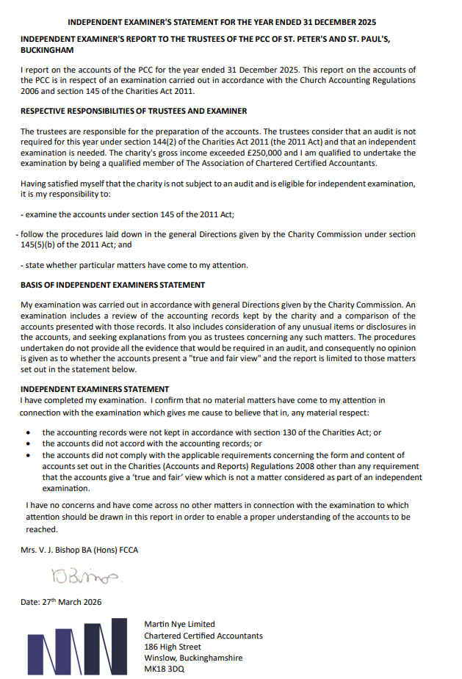

Financial Statements for the year ended 31 December 2025

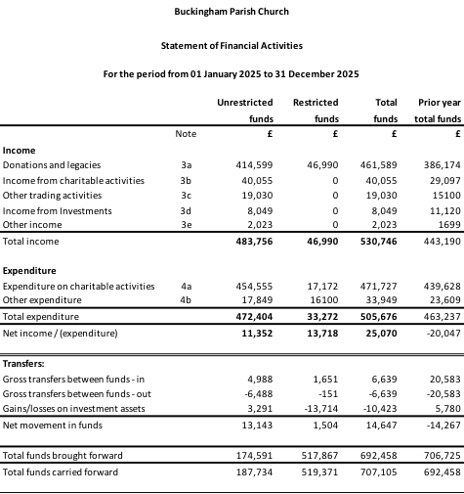

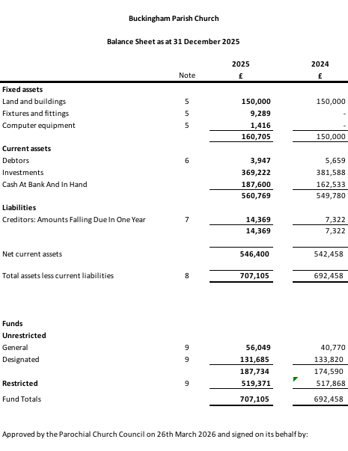

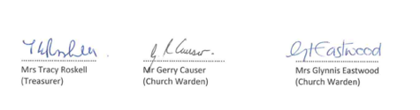
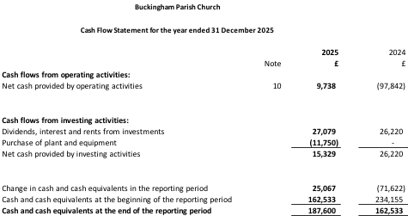

BUCKINGHAM PARISH CHURCH

General notes to the accounts

1 Basis of accounting
The financial statements have been prepared under the historical cost convention with items recognised at cost or transaction value unless otherwise stated in the relevant note(s) to these accounts. The Charity’s functional and presentation currency is pounds sterling, and the accounts are rounded to the nearest whole pound.

The financial statements have been prepared in accordance with the Church Accounting Regulations 2006 together with the Statement of Recommended Practice: Accounting and Reporting by Charities preparing their accounts in accordance with the Financial Reporting Standard applicable in the UK and Republic of Ireland (FRS 102) (effective 1st January 2019), the Financial Reporting Standard applicable in the UK and Republic of Ireland (FRS 102) and the Charities Act 2011.

The financial statements have been prepared to give a 'true and fair' view and have departed from the Charities (Accounts and Reports) Regulations 2008 only to the extent required to provide a 'true and fair' view. This departure involved following the Charities SORP (FRS102) published in October 2019 rather than the Accounting and Reporting by Charities: Statement of Recommended Practice effective from 1 April 2005 which has since been withdrawn.

The PCC is a public benefit entity as defined by FRS 102.

Charity information
Buckingham Parish Church is a charity registered with the Charity Commission on 20th March 2009.
Charity number 1128704.

Corporation Tax
The Charity is exempt from Corporation Tax on its charitable activities.

Judgements and key sources of estimation uncertainty
In the application of the Charity’s accounting policies, the Trustees are required to make judgements, estimates and assumptions about the carrying amount of assets and liabilities that are not readily apparent from other sources. The estimates and associated assumptions are based on historical experience and other factors that are considered to be relevant. Actual results may differ from these estimates. The estimates and underlying assumptions are reviewed on an ongoing basis. Revisions to accounting estimates are recognised in the period in which the estimate is revised where the revision affects only that period, or in the period of the revision and future periods where the revision affects both the current and future periods.

Other trading activities
Rental income from the hiring of PCC premises is recognised when the rental is due.
Income for events and fees for services is accounted for on an accruals basis.
Property rental is recognised on an accruals basis.

Current asset investments
The charity has cash and cash equivalent investments. These include cash on deposit and cash equivalents with a maturity of less than one year held for investment purposes rather than to meet short-term cash commitments as they fall due, these are valued at fair value.
Short-term deposits include cash held on deposit with the CCLA CBF Deposit Fund, or at the bank.

Tangible fixed assets for use by the charity

Land and buildings and other church property
The PCC is the beneficial owner and has the right to use the house in Chandos Close (known as the Curate’s House) which is held in trust for the PCC. The house is included in fixed assets on the basis of economic substance taking precedence over legal form at its fair value of £150,000.

Computer equipment, Fixtures & Fittings and Other equipment
Tangible fixed assets are measured at cost less accumulated depreciation and any accumulated impairment losses. Depreciation is provided at rates calculated to write off the cost of the fixed assets, less their estimated residual value, over their expected useful lives on a straight-line basis as follows:

Computer equipment 3 years
Fixtures & Fittings 3 to 5 years
Other equipment 5 years

Individual items with a purchase price of £1,000 or less are written off when the asset is acquired.

Payment to Examiner
An accrual of £1,200 (£1,000 + VAT) (2024: £1,200) is included in the accounts in respect of payment to examiner.

Going concern
The accounts have been prepared on a going concern basis and the PCC are happy that sufficient funds are held in both Undesignated and Designated Funds to ensure that the charity is able to continue to operate as a going concern.

Change of accounting policy
The accounts present a true and fair view, and no changes have been made to the accounting policies adopted in these notes.

2 Accounting Policies

Income
Funds
Unrestricted funds consist of a General Fund which the PCC may use, for the furtherance of the objects of the PCC, at its discretion. Designated funds are unrestricted funds which have been allocated for future expenditure for a specific purpose by the PCC. Restricted funds are subject to specific conditions imposed by the donors or by terms of an appeal, these conditions being legally binding upon the PCC.
The accounts include all transactions, assets and liabilities for which the PCC is responsible in law.

Recognition of income
Donations are recognised when received by or on behalf of the PCC. There has been no offsetting of assets and liabilities, or income and expenses, unless required or permitted by FRS 102. Grants and Legacies are accounted for when the PCC is notified of its legal entitlement and the amount due is quantifiable and its ultimate receipt by the PCC is probable.

Tax reclaims on donations and gifts
Gift Aid receivable is included in income where there is a valid declaration from the donor. Any Gift Aid amount recovered on a donation is considered to be part of that gift and is treated as an addition to the same fund as the initial donation unless the donor or the terms of the appeal have specified otherwise.

Volunteer help
The value of any voluntary help received is not included in the accounts but is described in the trustees’ annual report.

Income from interest and dividends
Dividends and interest are accounted for when receivable.

Investment gains and losses
This includes any realised or unrealised gains or losses on the sale of investments and any gain or loss resulting from revaluing investments to market value at the end of the year.

Expenditure and Liabilities

Expenditure
Expenditure is accounted for on an accruals basis. The Diocesan Parish Share contribution is accounted for when paid. All other expenditure is generally recognised when it is incurred. The charity measures creditors at settlement amounts.

Provisions for liabilities
A liability is measured on recognition at its historical cost and then subsequently measured at the best estimate of the amount required to settle the obligation at the reporting date.

UK & Overseas Mission
As a church we aim to give 10% of our annual income (excluding restricted / dedicated income) to support the work of other charities locally and overseas.

Pension costs
The charity makes defined contribution pension payments for eligible employees. Once the contributions have been paid, the charity has no further obligations. The contributions are recognised as an expense in the period.

The charity participates in the Pension Builder Scheme section of the Church Workers Pension Fund (CWPF) for lay staff. The CWPF is administered by the Church of England Pensions Board, which holds the CWPF assets separately from those of the Employer and other participating employers.

Pension Builder 2014 is a cash balance scheme that provides a lump sum which members use to provide benefits at retirement. Pension contributions are recorded in an account for each member. Discretionary bonuses may be added before retirement, depending on investment returns and other factors. The account, plus any bonuses declared is payable, unreduced, from age 65.

There is no sub-division of assets between employers in each section of the Pension Builder Scheme.

The scheme is considered to be a multi-employer scheme as described in Section 28 of FRS 102. This is because it is not possible to attribute the Pension Builder Scheme’s assets and liabilities to specific employers and means that contributions are accounted for as if the Scheme were a defined contribution scheme. The pensions costs charged to the SoFA in the year are the contributions payable (2025: £6,559, 2024: £6,055).

A valuation of the Pension Builder Scheme is carried out once every three years. The most recent valuation was carried out as at 31 December 2022.

For the Pension Builder 2014 section, the valuation revealed a surplus of £8.5m on the ongoing assumptions used. There is no requirement for deficit payments at the current time.

The Church of England Pensions Board has agreed that some employers could use assets in the DBS of the CWPF in lieu of contributions to Pension Builder Classic and/or Pension Builder 2014. Scheme members are able to see this information on their DBS statement which is sent separately.

The next valuation was due as at 31 December 2025, but has yet to be received.

The legal structure of the scheme is such that if another employer fails, the charity could become responsible for paying a share of the failed employer’s pension liabilities.

Irrecoverable VAT
In common with similar organisations, the charity is not able to reclaim most of the VAT it incurs. Irrecoverable VAT is treated as expenditure in the principal activity that incurred the original VAT.

Debtors
Amounts owing to the PCC at 31 December in respect of fees, rents or other income are shown as debtors which are measured on initial recognition at settlement amount.

Reserves Policy
The Trustees have agreed that the reserves policy should enable the funding of the equivalent of three months’ costs (approximately £120k).
At the end of 2025, our total reserves were £707k (2024: £692k), of which £188k (2024: £174k) are regarded as free reserves and £519k (2024: £518k) are restricted funds. We therefore have sufficient funds to comply with our reserves policy.

Details of funds held by the PCC:

General Fund
The General Fund is where our everyday income and expenditure goes through and represents the “current account” for the church. The closing balance on the fund stands at £56,049 (2024: £40,770).

Designated Funds

Curates Fund
This fund is for the maintenance and repair of the Curates House and also provides funds for the curate’s expenses. At the end of the year the fund stood at £14,769 (2024: £7,951).

Projects Fund
This fund was set up to provide a specific fund for PCC Projects. No legacy money was added in 2025. During the year £5,409 has been used by projects designated by the PCC. At the end of the year the fund stood at £47,864 (2024: £53,273).

The Centre
This was set up to hold funds for the ongoing missionary work in The Centre, Verney Close. The fund stands at £18,395 (2024: £17,185).

Food Bank
This was set up to hold funds for the ongoing missionary work at the Food Bank, based in the Centre. Following the significant grants received in the Covid and post Covid period the food bank balance has now been stabilised. Regular grants are no longer being received and the balance will continue to reduce, whilst still ensuring the food bank remains sustainable. The fund stands at £35,536 (2024: £40,093).

Restoration
This part of the restoration fund is unrestricted. The fund stands at £14,738 (2024: £14,738).

Rector’s Discretionary
This fund has received specific donations from members of the congregation which the rector has used to help members of the parish at his discretion. The fund stands at £382 (2024: £579).

Restricted Funds

Trust Funds
Gains on investments recorded relate to variations in share prices of investments held by the Central Board of Finance (CBF).

The Harrison Bequest
Is a Trust fund held by the Oxford Diocesan Board of Trustees for the provision of a curate. The income from the trust can be used ‘for providing the stipend of a curate in the parish and subject thereto for any ecclesiastical purpose in the parish as the PCC shall decide’.

The capital is not expendable by the PCC, but the interest is paid into the Assistant Curate’s Fund. The Charity Commissioners and the Diocese agreed in 2001 that the sum of £50,000 could be advanced from the capital of this fund to the Open Door (Redevelopment) Project, subject to the recoupment of £1,500 annually until 2036 from the interest of the residual capital of the fund, to be reinvested as a permanent endowment of the charity (as above). At the year end the amount to be recouped stood at £16,500 and the investment is valued in the accounts at £312,649 (2024: £324,944). During the year the trust fund made a loss of -£13,715 (2024: gain of £5,346).

Restoration Restricted
The Restoration fund stood at £14,492 (2024: £14,413).

Funeral
This fund is used to collect money from funerals where the families have specifically requested donations for charities of their choice. These are held by the PCC and then paid out as requested.

Special
This fund is used for special collections, like the Christingle, Christian Aid etc where the money is then distributed to the relevant charities. It is also used where money has been donated for specific causes, for example money donated for the stained-glass windows, mini-bus, ministry trainee. The balances amounted to £42,229 (2024: £28,511).

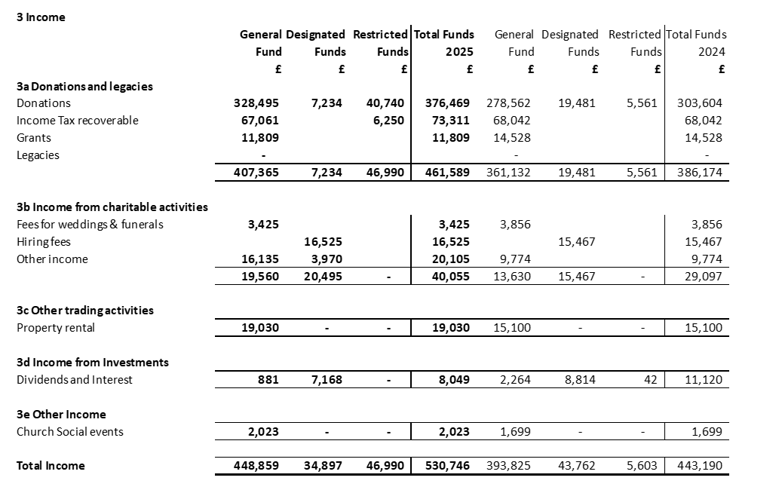

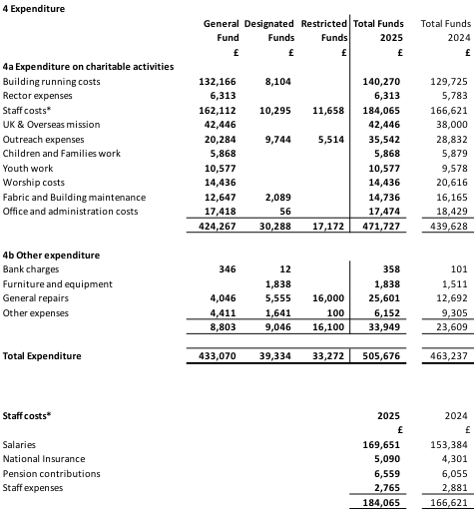

Average number of employees
The average number of employees during the year was 12 (2024: 11), which included: a Production Assistant & Worship Administrator; an Organist; Associate Minister for Pastoral Care; Children and Families Worker; Youth Worker; Operations Manager; Office Administrator; the Rector’s PA; Ministry Assistant; 2 Cleaners and a Caretaker for The Centre.

No employees received employee benefits for the reporting period of more than £60,000. Neither Vicar nor any Curate (when applicable) is included in the total salaries. This is because these stipends are met under Church of England arrangements and not by the PCC.

40 staff and volunteers were reimbursed £21,999 (2024: £21,457) in respect of mileage, and out of pocket expenses including general expenses, travel and asset purchases. Reimbursed expenses are incurred in order for staff and volunteers to fulfil their duties and are not considered payment for goods and services or the remuneration of a Trustee, nor do they count as any kind of personal benefit.

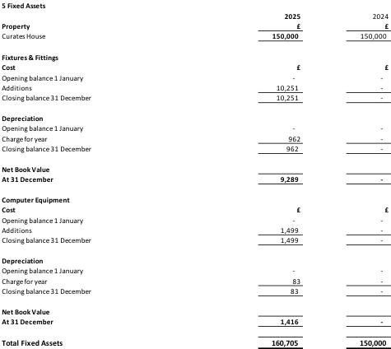
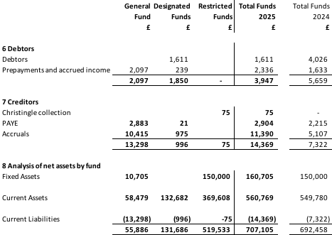

9 Fund statement of change

